Iowa Heirs Girls Basketball Program
2012 Summer/Fall Tryouts
3rd Grade through 11th Grade
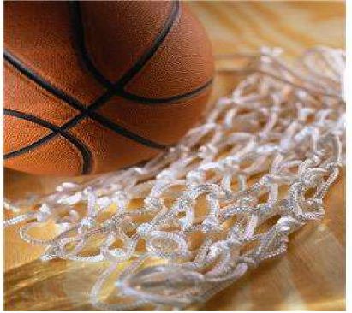
Are you are looking for a top notch program to get your daughter(s) involved in with? You have come to the right place!
The Iowa Heirs Basketball Program (IHBP) is a non-profit program that houses year-round basketball fundamental clinics, as well as, recreational and competitive basketball teams. In addition to one on one mentoring with women coaches and athletes who have actual collegiate experience and have been extremely successful!
When: Monday, June 19, 2012 & Thursday, June 21, 2012
Where: John R. Grubb YMCA, located at 1611 11th Street, Des Moines, IA 50314 Time: 6:30pm - 8:30pm
Tryout
Fee: $10/child or $15/family for those with 2 or more siblings trying out
FYI
- Grade level based on academic year 2012-13
- Please have your athlete arrive 30 min prior for registration and photos
- Please, bring your own ball if you have one.
If you have any questions or concerns please contact: Herkisha Burkett 515-729-8757 or theiowaheirs.basketball@gmail.com

